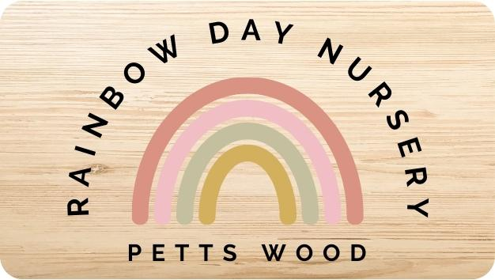
2024 Diary Dates
Date | Nursery Events
Monday 1st January 2024 | Bank Holiday (Nursery Closed)
Tuesday 2nd January 2024 | Nursery Re-opens after Christmas Break
Thursday 28th March 2024 | Staff Training Day (Nursery Closed)
Friday 29th March 2024 | Bank Holiday – Good Friday (Nursery Closed)
Monday 1st April 2023 | Bank Holiday – Easter Monday (Nursery Closed)
Monday 6th May 2024 | Bank Holiday (Nursery Closed)
Monday 27th May 2024 | Bank Holiday (Nursery Closed)
Saturday 29th June 2024 | Nursery Fun Day
Friday 2nd August | Rainbow Room Graduation (School Leavers)
Monday 26th August 2024 | Bank Holiday (Nursery Closed)
Monday 23rd December 2024 | Last Day before Christmas Break
Tues 24th December 2024 | Nursery Closed
Wednesday 25th – Thursday 26th December 2024 | Bank Holiday (Nursery Closed)
Friday 27th – Tuesday 31st December 2024 | Nursery Closed
Wednesday 1st January 2025 | Bank Holiday
Thursday 2nd January 2025 | Nursery Re-opens after Christmas Break

